2019 Belt & Road International Regatta Hobie®
Notice of Race
12th December-15th December 2019
Beihai, China

Sponsors
Chinese Yachting Association
Administration of Sport of Guangxi Zhuang Autonomous Region
People’s Government of Beihai
Organizer
Beihai Sports Bureau
Co-organizers
China Marine Sports Academy
Cambodia Sailing Federation
Malaysia Sailing Association
Singapore Sailing Federation
Yacht Racing Association of Thailand
Vietnam Canoeing, Rowing and Sailing Federation
Promoter
Beijing Mitime Sports Industry Investment Co., Ltd

- RULES
  - The regatta will be governed by the rules as defined in The Racing Rules of Sailing
  - The regatta will be governed by the rules as defined in IHCA Class Rules.
  - The participating teams shall abide by the relevant regulations on the use of vessel equipment, which also applies to the non competition period of participating vessels on the water.
  - The provisions of the governing bodies of the member states / regions shall not apply to this competition
  - If there is a conflict between languages the English text will take precedence.
- ADVERTISING
  - The organizing committee will post advertisements selected and provided by the Organizing Committee on the participating ships
  - Competitors can also display their own advertisements in accordance with Article 20 of the constitution of ISAF
  - Competitors can display the name, image or advertisement of their fleet on both sides of the hull, but the materials used for the stickers must be 3M or equivalent.
- ELIGIBILITY AND ENTRY
  - Local and international players (fleets) are welcome to sign up for this event on behalf of their countries, cities, clubs or shipowners agreed by the organizing committee
  - The organizing committee has set up both 30 hobie-t2 and hobie-getaway ship types.
  - The following information shall be provided when the qualified fleet applies:
    - Application form (electronic version),should sent to China Hobie level Association for application. And passed the qualification certification of China hobbie level Association.
    - Submit the disclaimer to the Organizing Committee at the time of registration. The Organizing Committee reserves the right to check the qualification and quantity of participating vessels
3.5 Registration deadline: the deadline for vessel and personnel registration is December 1, 2019.
Please send the application form before this time. See attachment D for the application form. After the registration is completed and confirmed by the organizing committee, the registration formalities will be completed. Subject to the order of application time, until the application is full.
- FEES
  - The entry fee of each team is 1000RMB (or equivalent foreign currency), which is also used as a ship deposit. After the competition is over and the ship is undamaged, it will be refunded in full as the completion reward. After the organizing committee confirms that the team has obtained the qualification, the application fee shall be transferred to the account designated by the organizing committee at the latest before December 3, 2019
  - Bank Account
Account Name：Beijing Mitime Sports Investment Co.,LTD
Name of Bank：Shanghai Pudong Development Bank Beijing Zhichun Road sub-branch
Account Number：9117 0154 7400 0228 3
  - Accommodation during the event will be arranged by the organizing committee.
  - When completion of the above payment of the registration fee, the participating teams receive the valid confirmation letter from the organizing committee.
- Schedule
Hobie T2 & GETAWAY
Dec.12 ----Registration
10：00---16：30 Cleaned equipment、Practice
17:30 Technical Meeting
Dec.13 10:00-16:00 Racing
Dec.14 10:00-15:00 Racing
17:00 Awarding ceremony
Dec.15 All Day Departure
- Measurement and equipment regulations
6.1 If the equipment needs to be replaced in case of damage, a written application shall be submitted to the competition committee, and the damaged equipment and the new equipment to be replaced shall be submitted to the Technical Committee for inspection. Then it will be replaced by the organizing committee.
6.2 It is allowed to bring the spherical sails that meet the requirements of the level rules, but they can only be used when was measured before the competition.
6.3 The quality of the equipment provided by the organizing committee shall not be taken as the reason for claiming compensation.
7.Navigation Details
It will be sent to each participating team and athletes when finish registration.
8.Courses
8.1 Appendix A is the schematic diagram of competition area.
8.2 the competition committee may move the site location for meteorological or safety reasons.
9.Sailing Route
Please refer to navigation details.
10.Penalty System
10.1 For the RRS 44.1 is changed so that the Two-Turns Penalty is replaced by the One-Turn Penalty.
10.2 Final result will depend on Arbitration Commission
11.Score
11.1 One race is required to be completed to constitute a series. There will be 7 races in total.
11.2 When fewer than five races have been completed, a boat’s series score will be the total of her race scores.
11.3 When five or more races have been completed, a boat’s series score will be the total of her race scores excluding her one worst score.
12. Auxiliary Boat
The auxiliary boats used by the leaders, coaches and other team official. It must avoid the competition area after the signal of preparation for the first level of competition is sent until all boats pass the destination, or before the bid committee sends the signal of delay, full recall or abandonment. The boat must avoid the racing courses.
13. Park the Boat
Competitors should park their boats in the official berthing area.
14.Radio Communication
Except in an emergency, a boat that is racing shall not make voice or data transmissions and shall not receive voice or data communication that is not available to all boats. Channel VHF72 is belongs to organizing committee used for work,all boats are allowd to listen the channel during the racing.
15. Award
Hobie-T2
1st：(After Tax)RMB8000 with trophy
2nd：(After Tax)RMB5000 with trophy
3rd：(After Tax)RMB4000 with trophy
4th：(After Tax)RMB3000
5th：(After Tax)RMB2000
6th：(After Tax)RMB1000
Hobie-getaway
1st：(After Tax)RNB8000 with trophy
2nd：(After Tax)RMB5000 with trophy
3rd：(After Tax)RMB4000 with trophy
4th：(After Tax)RMB3000
5th：(After Tax)RMB2000
6th：(After Tax)RMB1000
16.Safety
All competitors must wear life jackets when they are on the water and these life jackets shall be fastened according to the operation specifications.
17. Disclaimer of Liability
Competitors participate in the regatta entirely at their own risk. See RRS 4,Decision to Race. The organizing authority will not accept any liability for material damage or personal injury or death sustained in conjunction with or prior to, during, or after the regatta
18.Insurance
Each participating boat shall be insured with valid Personal accident insurance in Racing Area with a minimum coverage of 500,000 RMB per incident or the equivalent.
19. Relevant rights
All the participating in this competition will automatically agree to the organizer and its sponsors to use their names, portraits and other materials free of charge when making, using and displaying plane and various multimedia products (including live broadcast, video recording and TV movies) during the competition
20.Dressing
All participants should wear formal clothes or team uniforms when attending the opening / closing ceremony or party.
21. Environmental responsibility
Based on the principle that participants should try their best to minimize the adverse impact on the environment. There will be no small bottled drinking water for this event. The organizing committee will only provide buckets of water on the land, and provide portable food grade plastic water storage bags for participants on the water.
22.Information
For entry and more information, please contact the OC as the following detail:
Contact person : Zhang Yu
Tel: +86 18078499539
E-mail: brr@mitime.com.cn
Contact person: Zhao Anqi
Tel: +86 15201103922
E-mail: brr@mitime.com.cn

Appendix A - schematic diagram of competition area

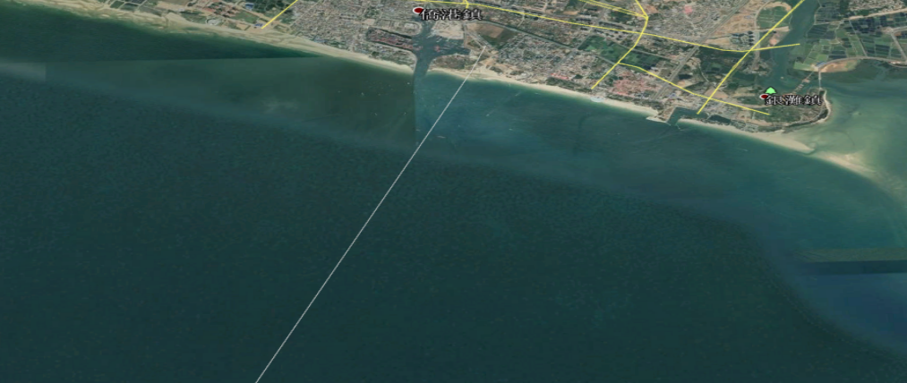

Appendix:BRR Beihai HOBIE Racing Courses
1 |  | (S) | A C A |  |  | (F) | Downwind 1 | G | 1 O | 1 | GO
2 |  | (S) | A C A | C A |  | (F) | Downwind 2 | G | 2 O | 2 | GO
3 |  | (S) | A C A | B C |  | (F) | Upwind |  | 3 O
4 |  | (S) | A B C | A C |  | (F) | Upwind |  | 4 O
5 |  | (S) | A C |  |  | (F) | Upwind 5 | G | 5 O | 5 | GO
6 |  | (S) | A C A | C |  | (F) | Upwind 6 | G | 6 O | 6 | GO
7 |  | (S) | A C A | B C A C |  | (F) | Upwind |  | 7 O

IHCA Standard Courses
S = start, A = weather mark, B = reaching mark, C = leeward mark, G = gate, F = finish, O = offset mark is used.
"B" MARK LOCATION: The Race Committee will endeavour to locate "B" Mark, the reaching mark, at either the windward or leeward end of the course approximately 90 to 105 degrees abeam of the windward or leeward mark.

Appendix D
2019 Belt & Road International Regatta •Beihai HOBIE Entry Form

2019（ENTRY FORM）

Club/ Team name:
Country / City:
Address: Post Code:
Tel\Phone: Fax: E-mail:

Crews/Skipper | Name | Gender (M/F) | IDcard/passport No. | Class | Nationality
Skipper
Crew
Decision:
I agree to be bound by the international regulations for preventing collisions at sea, the rules of ISAF competition, the special rules of ISAF offshore competition, the notice of competition, the rules of navigation and the rules of class. I understand that the Organizing Committee of the 2019 "Belt and Road" International Regatta •Beihai will not be held responsible for the safety and physical damage of the participants, as well as the damage to the vessels and equipment involved. I declare that I will have valid insurance (including third party liability insurance, with a minimum amount of 500000 yuan) during the competition. My team also understands the above statement. At the same time, abide by the organizing committee's activities in this event.

Signature & Stamp of the Club：________________________

ENTRY Date:________________________

Please finish the form and signed then send to the E-mail Address：brr@mitime.com.cn

Contact person：Zhang Yu
Phone：+86-18078499539

