2019 Belt & Road International Regatta (Beihai)

NOTICE OF RACE
10th December-15th December 2019
Beihai, China

Sponsors
Chinese Yachting Association
Administration of Sport of Guangxi Zhuang Autonomous Region
People’s Government of Beihai
Organizer
Beihai Sports Bureau
Co-organizers
China Marine Sports Academy
Cambodia Sailing Federation
Malaysia Sailing Association
Singapore Sailing Federation
Yacht Racing Association of Thailand
Vietnam Canoeing, Rowing and Sailing Federation
Promoter
Beijing Mitime Sports Industry Investment Co., Ltd

- RULES
  - The regatta will be governed by the rules as defined in The Racing Rules of Sailing (RRS) 2017-2020.
  - The IRC Rules of Part A, B & C；Except that IRC Rule 22.4 will not apply. There
will be no limitations on crew number or weight except as required for boats rated;
  - Teams are required to comply with the relevant regulations for the use of boats and equipment, and this applies also to non-racing periods of participating boats on the water.
  - Add rule 41(e): Crew overboard will be helped to return to the ship near the rescue site.
  - The prescription of the National or Regional Yachting Association will not apply;
  - Race documents will be published in both Chinese and English. In case of conflict between languages, the English text will take precedence.
  - Teams shall be self-equipped with Lifejackets conforming to ISO1402-5 or higher standard and VHF marine walkie talkie.

- ADVERTISING
  - Boats may be required to display advertising chosen and supplied by the OC.
  - Advertising displayed on a boat (hull, sails and boom) or on crew-wear during the event is permitted in accordance with WORLD SAILING Regulation 20 of Advertising Code.
  - Teams may display their team’s Name or Image or Logo or other advertisings on both sides of the hull, with 3M (or same quality) advertising material; display sites will be detailed in Appendix C.

- ELIGIBILITY
  - The Regatta is open to boats that may be representing a country/a city/a club or an individual boat owner.
  - Regatta is open to J80 class boat with third-party liability insurance. The boat of J80 Class will be provided by the OC, for a total of 14 boats. The OC will allow teams to participate with their own boat of the same class. Regatta is open to Dubois 50 One-Design Class, and Open Class. The boat of Dubois 50 One-Design Class will be provided by the OC, for a total of 6 boats.The Open Class will be entered by the team with their own boat that meets the requirements of the OC, for which the OC will provide subsidies. All the participating boats shall have a valid IRC Rating Certificate.
  - When the boats enter and register on-site for one class (group) is less than 4, the event of that class (group) will be cancelled.
  - The Number of Crews
Table below lists the minimum and maximum number of crews on board while racing
Class | Min numbers | Max numbers
J80 | 4 | 6
Open | 6 | 10
For J80 Class, each boat shall have at least 1 helmsman with experienced inshore race sailing skills; For Open Class, each boat shall have at least 2 helmsmen once completed the World Sailing Category 4 event or having the helmsman experience in accordance and with 30% of the crews have offshore race experience.
  - Eligible team shall submit the following information to the OC:
- Entry Form (Electronic Version), photo and introduction of your team (within 400 words, photo of crews and VCR).
- Self-prepared boat shall have their boat’s certificate and insurance (photo copy) prescribed as NOR 18.
- Crews’ race experience declaration; Valid crew safety and lifesaving training certificate; Valid crews' ID/passport; Ship-owners or experienced crew for Open Class shall provide valid yacht driving licenses such as AIF,ASA, CYA, RYA or at least a certificate for offshore masters;
- Paper Entry Form with signature of boat owner or the person in charge and the Disclaimer of Liability for crew shall be provided at On-Site Registration. OA reserves the right to decline the entry due to the eligibility and number of the charted boats.
  - Entry deadline: 1st December 2019.
Entry Form shall be received no later than that day. Appendix D is the Entry Form. Entry Procedure will be completed when receiving the confirmation of OA. first come, first serve.

- FEES
- Entry fee for each competitor is 3000 RMB (or equivalent foreign currency). Teams that have entered may pay the entry fee no later than 3rd December, 2019 by bank transfer.
- Teams for J80 class shall pay the equipment damage deposit at the on-site registration. The equipment damage deposit is 5000RMB (or equivalent foreign currency). It will be fully returned if equipment has no damage after the regatta. When damage occurred, according to the damage to the equipment, only part of, or no damage deposit will be returned.
- Boat rental fee for pre-event training is 1000RMB per day and can be paid in cash on site.
- You may pay the entry fee by bank transfer in advance. Bank transfer information is as follows:
Account Name：Beijing Mitime Sports Investment Co.,LTD
Name of Bank：Shanghai Pudong Development Bank Beijing Zhichun Road
sub-branch
Account Number：9117 0154 7400 0228 3

- Accommodation fee during the event will be paid by the OC
- Teams will receive the conformation letter from the OC after paying the entry fee above.

- SCHEDULE
Date/Time | Activity | Place
D1 Tuesday 10th December 2019 | Registration
D2 Wednesday 11th December 2019 | Registration, Boats Draw, Boat Distribution, Practice
1600 | Skipper Meeting
D3 Thursday 12th December 2019 | Signal Racing
1100 | Racing
D4 Friday 13th December 2019 | Racing Day
0900 | Opening Ceremony
1000 | Racing
D5 Saturday 14th December 2019 | Racing Day
1100 | Racing
D6 Sunday 15th December 2019 | Departure

- MEASUREMENT
- Written application for substitution of the damaged equipment may be permitted provided the damaged equipment has been checked by the chief measurer. Such substitution will be taken by OA if necessary.
- Teams may bring their own spinnaker pole that complies with the class rule, but the spinnaker pole should be measured before racing.
- No ground of redress shall be made on the quality and failure of the chartered equipment.

- SAILING INSTRUCTIONS (SIs)
The SIs will be available at registration. The SIs may be published on the official website: http://www.mitimegroup.com/business/47/ before the registration day.

- VENUE
- Appendix A shows the venue of racing.
- The Race Committee may move the racing area to other location due to weather or safety reasons.

- COURSE
The course will be published in the SIs.

- PENALTY SYSTEM
- Rule 44.1 is changed so that Two-Turns Penalty is replaced by the One-Turn Penalty.
- The decisions of the Jury will be final.

- SCORING
- J80 class racing has 8 course races (including LDR). One race is required to be completed to constitute a series for the Course races.
- When fewer than 5 races have been completed, a boat’s series score will be the total of her race scores for course races.
- When 5 or more races have been completed, a boat’s series score will be the total of its race scores excluding its worst score for course racing.
- LDR will be set as an inshore race and will be scored separately, but without any prize.
- Open Groups will have 2 races: course race and round island race. Both the two races will be counted to the total scores.
- For IRC Classes the race real time of each boat will be corrected by its IRC TCC for the ranking.

- SUPPORT BOATS
Team leaders, coaches and other support personnel, with their boat, shall stay outside areas where boats are racing from the time of the preparatory signal for the first class to start, until all boats have finished or the race committee signals a postponement, general recall or abandonment.

- BERTHING
Boats shall be kept in their assigned places or other designated area.

- RADIO COMMUNICATION
Except in an emergency, a boat shall neither make radio transmissions while racing nor receive radio communications not available to all boats. VHF72 will be the emergency call channel for this event. Boats may listen to this channel while racing.

- PRIZES
J80 Class
1st place: 30000RMB (AT) and Trophy
2nd place: 20000RMB (AT) and Trophy
3rd place: 10000RMB (AT) and Trophy
4th place: 8000RMB (AT)
5th place: 7000RMB (AT)
6th place: 6000RMB (AT)
7th place: 5000RMB (AT)
8th place: 4000RMB (AT)
Finish event prize: 1000RMB (AT)
Dubois50 One-Design Class
Top 3 winners will be awarded with permanent trophies.
Open Class
1st place: 30000RMB (AT)
2nd place: 20000RMB (AT)
3rd place: 10000RMB (AT)
Finish event prize: 5000RMB (AT)

- SAFETY
While afloat, all competitors shall by themselves bring their own life jacket in comply with the ISO 12402-5 standard or higher and wear it which must be capable of being fastened at all time while afloat.

- DISCLAIMER OF LIABILITY
All those taking any part in the event do so at their own risk. See RRS 4, Decision to Race. The OA will not accept any liability for material damage or personal injury or death sustained in conjunction with or prior to, during, or after the regatta.

- INSURANCE
- Each self-prepared participating boat shall be insured by the team with valid third-party liability insurance within competition area with a minimum coverage of the value of the boat.
- Each participating sailor shall be insured with valid personal accident insurance with a minimum coverage of 500,000RMB per competitor.

- RIGHT TO USE NAME AND LIKENESS
By participating in the regatta, a competitor automatically grants to the OA and its sponsors the right in perpetuity to make, use and show, from time to time at their discretion, any motion pictures and live, taped or filmed television and other reproductions of the athlete during the period of the competition without compensation.

- DRESS CODE
Sailors and participant are encouraged to dress in teams’ uniform while participating in the ceremonies and the social activities. Blazer and tie is welcome.

- ENVIRONMENTAL RESPONSIBILITY
To cut environmental damage to the lowest, the regatta will not provide bottle water for the event. The OC will provide barreled water on land and water storage tank on board. Competitors may need to bring their own water bottle/cup.

- INFORMATION
For entry and more information, please contact the OC as the following detail:

Contact person : Zhang Yu
Tel: +86 18078499539
E-mail: brr@mitime.com.cn

Contact person: Zhao Anqi
Tel: +86 15201103922
E-mail: brr@mitime.com.cn

Appendix A: Course Racing Area
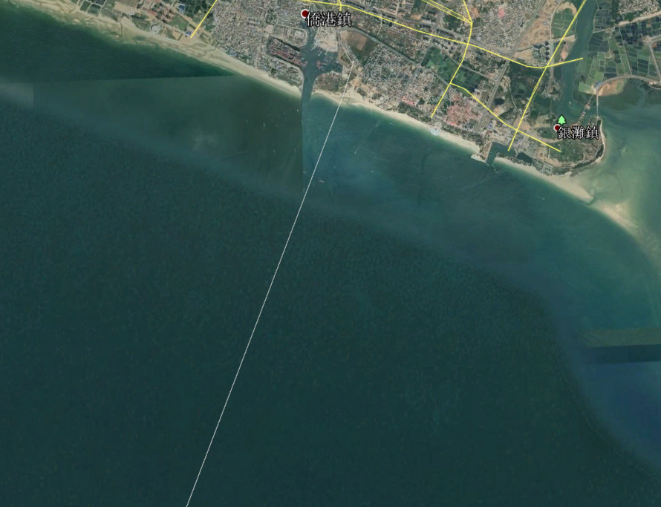
Appendix B: Starting Point/Finishing Point/Retrace Point

Appendix C: ‘TEAM’ Space on Each Side of the Hull

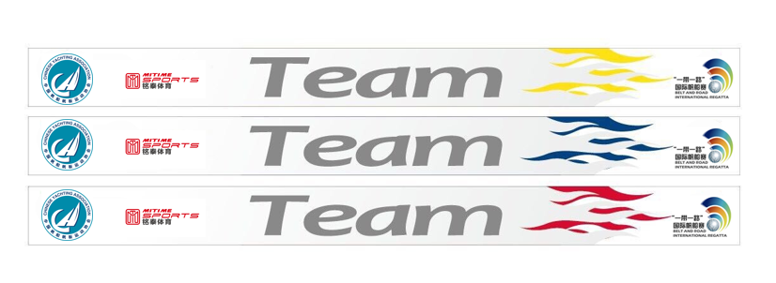
Appendix D:
2019 Belt & Road International Regatta •Beihai Entry Form
2019报名表（ENTRY FORM）

俱乐部/参赛队名称Club/ Team name:
国家/城市Country / City: 帆号 Sail No.:
地址Address: 邮编Post Code:
电话Tel: 传真Fax: 邮箱E-mail:

船员/舵手  Crews/Skipper | 姓名  Name | 性别  Sex (M/F) | 身份证/护照号码  IDcard/passport No. | 级别  Class
Skipper
Crew
Crew
Crew
Crew
Crew
Crew
Crew
Crew
Crew
Crew
领队(Team Leader):
教练(Coach):
Participating Decision：I agree all constrains of International Regulations for Preventing Collisions at Sea（COLREGS）, World Sailing Racing Rules of Sailing, World Sailing Offshore Special Regulations, NOR, Sailing Instructions and Class Rules. I understand the Organization Authority of “Belt & Road ”International Regatta•Beihai will neither be responsible for life security and body injury of competitors nor boat and equipment damage. I declare that I will hold valid insurance during the race (include third-party liability insurance with a minimum cover of 500, 000RMB). My team also understands the declaration above. Meanwhile, we will participate all activities which are required by regatta.

俱乐部/领队 签、章Signature & Stamp of the Club：________________________
报名日期ENTRY TIME:________________________
请将此表于2019年12月1日前发送至以下电子邮箱
Please sent this form to the following E-mail address before 1stDecmber2019： brr@mitime.com.cn；Contact person : Zhang Yu ；Tel: +86 18078499539

